**Elasticity of cantilever**

**Note : Please ensure the data and the answers must be expressed by scientific notation and SI unit. The unit of length should be meter.**

**Part A. Alignment of light path**

Please design a light path so that the laser spot hits the middle of the reflective area of the cantilever beam. Make sure the laser spot can stably appear near the origin of the PSD display screen and draw

the relative position (coordinates and angles) of each component on the answer sheet.

**A.1** (0.6 pt)

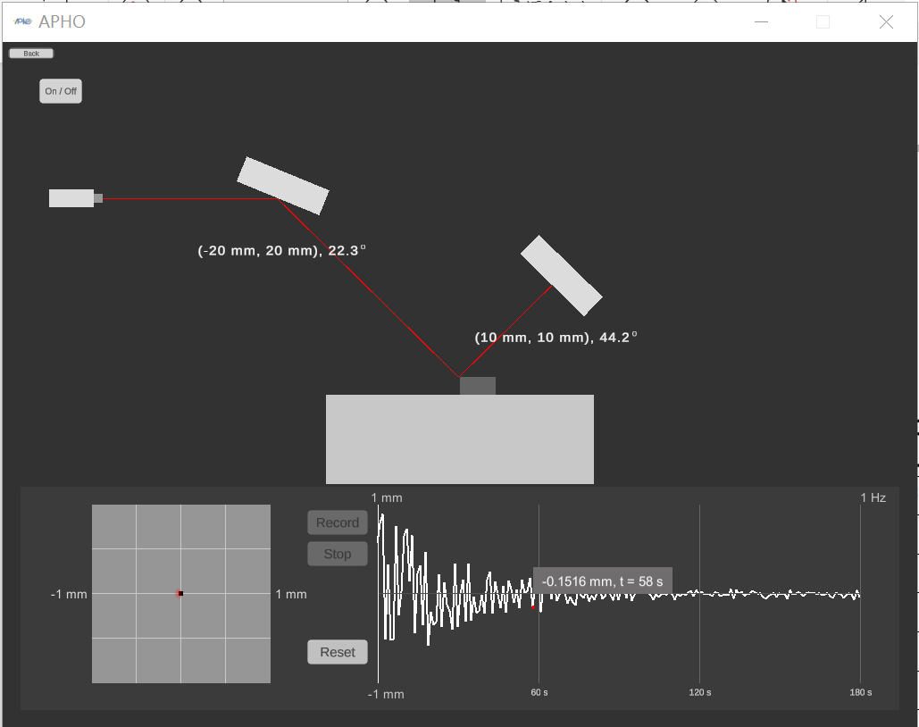

## A.2

𝑑

(0.8 pt)

Since the cantilever beam will be disturbed when the device turned on, it may take some time to reach a stable state. After the instrument is turned on, the figure of the position of the light spot on the PSD and time will be displayed at the bottom right of the program. Please record the position of the light spot on the PSD every 3 seconds under external disturbance after pressing the "Record" button. Please record at least 40 data points, and then press the "Stop" button to stop capturing data.

|  |  |  |  |  |  |
| --- | --- | --- | --- | --- | --- |
| time (s) | position 𝑑 (m) | time (s) | position 𝑑 (m) | time (s) | position 𝑑 (m) |
| 3 | -5.21×10-5 | 42 | -1.01×10-5 | 81 | 1.29×10-5 |
| 6 | 5.752×10-4 | 45 | 1.862×10-4 | 84 | 6.55×10-5 |
| 9 | -2.385×10-4 | 48 | -2.69×10-5 | 87 | 9.16×10-5 |
| 12 | 6.064×10-4 | 51 | 3.72×10-5 | 90 | 5.07×10-5 |
| 15 | 2.144×10-4 | 54 | 1.89×10-5 | 93 | 6.16×10-5 |
| 18 | 1.085×10-4 | 57 | -3.29×10-5 | 96 | 5.13×10-5 |
| 21 | 2.510×10-4 | 60 | 5.13×10-5 | 99 | 8.21×10-5 |
| 24 | -0.581×10-4 | 63 | 7.25×10-5 | 102 | 7.25×10-5 |
| 27 | -1.14×10-5 | 66 | -2.16×10-5 | 105 | 3.77×10-5 |
| 30 | 3.781×10-4 | 69 | -3.54×10-5 | 108 | -8.7×10-5 |
| 33 | 3.224×10-4 | 72 | 9.48×10-5 | 111 | 1.57×10-5 |
| 36 | 3.067×10-4 | 75 | 6.83×10-5 | 115 | 1.0×10-6 |
| 39 | -1.424×10-4 | 78 | 5.77×10-5 | 117 | 1.60×10-5 |
|  |  |  |  | 120 | 7.2×10-5 |
|  |  |  |  |  |  |

Please use the **stable segment** of the data obtained by **A.2** to find the reference value of measure-

ment of this cantilever beam under the fluctuation of the experimental environment. (

**age value of** 𝑑).

**A.3** (1.0 pt)

𝑑 **is the aver-**

**reference value of measurement (with standard deviation):**

|  |  |  |  |
| --- | --- | --- | --- |
| 𝑑 (m) | 𝑑 (m) | 𝑑 − 𝑑 (m) | standard deviation |
| 9.48×10-5 | 6.222×10-5 | 3.26×10-5 | 6.0×10-6 |
| 6.83×10-5 | 6.1×10-6 |
| 5.77×10-5 | -4.5×10-6 |
| 6.55×10-5 | 3.3×10-6 |
| 9.16×10-5 | 2.94×10-5 |
| 5.07×10-5 | -1.15×10-5 |
| 6.16×10-5 | -6.2×10-6 |
| 5.13×10-5 | -1.09×10-5 |
| 8.21×10-5 | 1.99×10-5 |
| 7.25×10-5 | 2.50×10-5 |

**Note : For the convenience of the measurement in the following experiments, we assume the cantilever has reached its stable state under the influence of the environmental perturbation,**

**i.e. the vibration of the optical components will not affect the measured value.**

**Note : Calculation of the standard deviation is not required in the following data analysis (Part B to Part D).**

# Part B. Deformation of cantilever beam and deduction of Young’s modulus

(1.0 pt)

## B.1

Please design the optical path when the external force is 0 N. Let the laser spot hit in the middle of the reflective area of the cantilever, and be sure about that the laser spot can stably appear near the center of the PSD display screen. Record the data on the table to obtain the measurement reference

value 𝑑 . The position of the light spot on the PSD at this time is set as the displacement Δ𝑑 = 00

. Then apply five different magnitudes of external forces on the cantilever, and record the experimental results in the table on the answer sheet.

|  |  |  |
| --- | --- | --- |
| 𝐹 (N) | 𝑑 (m) | ~~𝑑~~ = 𝑑0 (m) |
| 0 | -1.51×10-5 | -1.112×10-5 |
| 1.6×10-6 |
| -3.14×10-5 |
| 1.1×10-6 |
| -1.37×10-5 |

Then apply five different magnitudes of external forces on the cantilever, and record the experimen- tal results in the table on the answer sheet.

|  |  |  |
| --- | --- | --- |
| 𝐹 (N) | 𝑑 − 𝑑0 = Δ𝑑 (m) | ~~Δ𝑑~~ (m) |
| 1.80×10-9 | 2.0562×10-4 | 2.0800×10-4 |
| 2.1492×10-4 |
| 2.0182×10-4 |
| 2.1302×10-4 |
| 2.0462×10-4 |
| 3.60×10-9 | 4.1632×10-4 | 4.0940×10-4 |
| 4.0282×10-4 |
| 4.0292×10-4 |
| 4.1052×10-4 |
| 4.1442×10-4 |

|  |  |  |
| --- | --- | --- |
| 𝐹 (N) | 𝑑 − 𝑑0 = Δ𝑑 (m) | ~~Δ𝑑~~ (m) |
| 5.40×10-9 | 6.0982×10-4 | 6.1630×10-4 |
| 6.1032×10-4 |
| 6.1612×10-4 |
| 6.2802×10-4 |
| 6.1722×10-4 |
| 7.20×10-9 | 8.1222×10-4 | 8.1232×10-4 |
| 8.0452×10-4 |
| 8.1102×10-4 |
| 8.1712×10-4 |
| 8.1672×10-4 |
| 9.00×10-9 | 9.9822×10-4 | 1.00450×10-3 |
| 1.00412×10-3 |
| 1.01082×10-3 |
| 1.00622×10-3 |
| 1.00312×10-3 |

(the average of light spot displacement on the PSD) as the -axis.

**B.2** (1.0 pt)

Fill in the table. Make a plot by taking the magnitude of flexural deformation 𝛿 as the 𝑦-axis and Δ𝑑

|  |  |  |
| --- | --- | --- |
| 𝐹 (N) | 𝛿 (m) | Δ𝑑 (m) |
|  |  |  |
| 1.80×10-9 |  | 2.0800×10-4 |
| 3.60×10-9 |  | 4.0940×10-4 |
| 5.40×10-9 |  | 6.1630×10-4 |
| 7.20×10-9 |  | 8.1232×10-4 |
| 9.00×10-9 |  | 1.00450×10-3 |

**B.3** (0.4 pt)

Please deduce the 𝐶1 value from the optical leverage relationship 𝛿 = 𝐶1Δ𝑑, as illustrated in Figure

3.

C1=5.004×10-4

# Part C. Double layer cantilever beam

(1.0 pt)

## C.1

Δ𝑑 = 0

Please design a simple experiment diagram with light path. Let the laser beam show near the center

0, and used this reference as .

|  |  |  |
| --- | --- | --- |
| 𝑇 (K) | 𝑑 (m) | 𝑑 ̄= 𝑑0 (m) |
| 300 | -5.45×10-5 | -2.988×10-5 |
| 3.0×10-6 |
| -1.20×10-5 |
| -6.58×10-5 |
| -1.74×10-5 |

Then, increase the temperature to higher value, wait until the double layer beam stable then record the data. Try to do at least 5 different temperatures and record the data in the table of answer sheet.

|  |  |  |
| --- | --- | --- |
| 𝑇 (K) | 𝑑 − 𝑑0 = Δ𝑑 (m) | ~~Δ𝑑~~ (m) |
| 301 | 3.0798×10-4 | 3.1148×10-4 |
| 3.1618×10-4 |
| 3.0958×10-4 |
| 3.0498×10-4 |
| 3.1868×10-4 |
| 301.5 | 4.6838×10-4 | 4.6878×10-4 |
| 4.6718×10-4 |
| 4.7198×10-4 |
| 4.6458×10-4 |
| 4.7178×10-4 |

**A1**Englis**-**h (O**9**fficial)

|  |  |  |
| --- | --- | --- |
| 𝑇 (K) | 𝑑 − 𝑑0 = Δ𝑑 (m) | ~~Δ𝑑~~ (m) |
| 302 | 6.3008×10-4 | 6.3634×10-4 |
| 6.4098×10-4 |
| 6.4328×10-4 |
| 6.3828×10-4 |
| 6.2908×10-4 |
| 302.5 | 7.4638×10-4 | 7.5486×10-4 |
| 7.3828×10-4 |
| 7.6678×10-4 |
| 7.6518×10-4 |
| 7.5768×10-4 |
| 303 | 9.1548×10-4 | 9.2276×10-4 |
| 9.2938×10-4 |
| 9.3248×10-4 |
| 9.1478×10-4 |
| 9.2168×10-4 |

and in **B.3**.

**C.2** (1.0 pt)

Fill in the table. Make a plot by taking the magnitude of flexural deformation 𝛿 as the 𝑦-axis and the

temperature 𝑇 as the 𝑥-axis. By data analysis, find the slope. You can use the correlation between 𝛿

|  |  |  |
| --- | --- | --- |
| 𝑇 (K) | ~~Δ𝑑~~ (m) | 𝛿 (m) |
|  |  |  |
| 301 | 3.1148×10-4 | 1.575×10-7 |
| 301.5 | 4.6878×10-4 | 2.331×10-7 |
| 302 | 6.3634×10-4 | 3.184×10-7 |
| 302.5 | 7.5486×10-4 | 3.775×10-7 |
| 303 | 9.2276×10-4 | 4.614×10-7 |

Slope：1.504×10-7

C3: E=5.78×1010Pa

Use data from **C.2** to calculate the Young’s modulus for the upper layer material.

**C.3** (0.6 pt)

**Part D. Test of molecular-absorption-induced bending of a cantilever beam**

value 𝑑 measured in the tables of the data sheet. The displacement Δ𝑑 of the laser spot is set zero,

Design an optical path for Sample 0, so that the reflected laser spot locates at the center of the

Δ𝑑 = 0 at this position. Then repeat the experiment with Sample 1. Record your answers on the

r

**D.1** (0.6 pt)

eflection zone, i.e. the laser spot appears stable in the origin of the PSD screen. Record the base

tables of the data sheet. Note that Sample 1 has the highest coverage ratio (

0

𝐶𝑅) in all samples.

Assume the function form of the magnitude of flexural deformation 𝛿 and coverage ratio (𝐶𝑅) can

be expressed as : 𝛿 = 𝐶 𝐿 . Estimate 𝐶 based on your data obtained in **D.1**. You can use the

correlation between 𝛿 and Δ𝑑 in **B.3**

D2：-8.02×10-2

.

**D.2** (0.6 pt)

2

𝐶𝑅 4

𝐸𝐼

∗

2

|  |  |  |
| --- | --- | --- |
| Sample 0 | 𝑑 (m) | ~~𝑑~~ = 𝑑0 (m) |
| 3.75×10-5 | 9.06×10-6 |
| -1.54×10-5 |
| 1.21×10-5 |
| 1.91×10-5 |
| -8.0×10-6 |
| -  Sample 1 | 𝑑 − 𝑑0 = Δ𝑑(m) | ~~Δ𝑑~~(m) |
| -8.8706×10-4 | -8.7088×10-4 |
| -8.7956×10-4 |
| -8.7486×10-4 |
| -8.6156×10-4 |
| -8.5136×10-4 |

D2：-8.02×10-2

|  |  |  |
| --- | --- | --- |
| Sample 2 | 𝑑 − 𝑑0 = Δ𝑑 (m) | ~~Δ𝑑~~ (m) |
| -6.2536×10-4 | -6.2112×10-4 |
| -6.1846×10-4 |
| -6.2496×10-4 |
| -6.1656×10-4 |
| -6.2026×10-4 |
| -  Sample 3 | 𝑑 − 𝑑0 = Δ𝑑(m) | ~~Δ𝑑~~(m) |
| -2.1956×10-4 | -2.1610×10-4 |
| -2.1576×10-4 |
| -2.2476×10-4 |
| -2.1296×10-4 |
| -2.0746×10-4 |

Sample 3:

S3：0.248%

Sample 2:

S2:0.713%

S2：0.713%